**Name-Manish Kumar**

**Enrollment-2020ITB007**

**Assignment – 3**

**Intelligent Surveillance System**

1.Prepare the Data Flow Diagram (DFD) Model of your selected problem, up to 3 levels (Level 0,

Level 1, Level 2 DFDs).

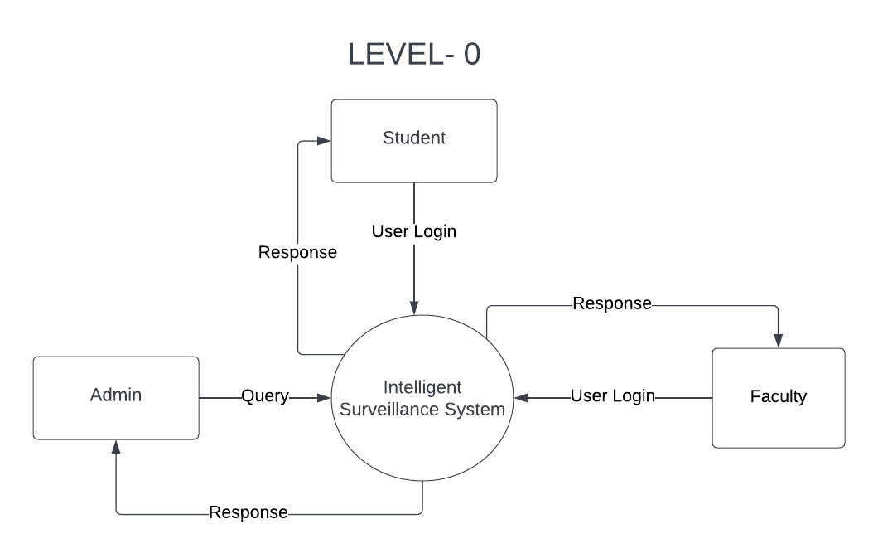

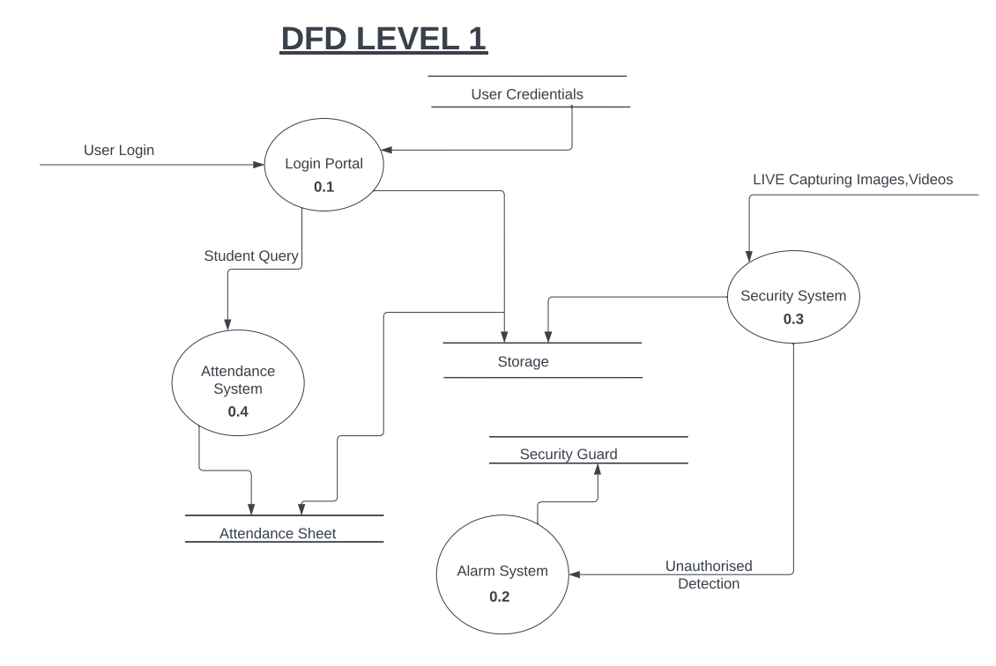

**2. Data Dictionary for Intelligent Surveillance System:**

This data dictionary provides a comprehensive list of the data elements used in the Intelligent Surveillance System. The system is designed to track human movement in the department, record arrival and departure time of research scholars and PG students, compute monthly attendance data for different types of students, and identify unauthorized movement, unauthorized entry, fire break out, or damaging of property within the department. Additionally, the system includes a wing to be used in classrooms for real-time automated attendance recording and semester-wise attendance calculation of UG students.

1. **Department:** A unit of the educational institution where the Intelligent Surveillance System is implemented.
2. **Human Movement:** The movement of individuals within the department, tracked through the use of cameras and sensors.
3. **Research Scholars:** Students pursuing research in the department.
4. **PG Students:** Post-graduate students in the department.
5. **Attendance Data:** Data that contains information about the attendance of students in the department, including arrival and departure times.
6. **Monthly Attendance Data**: Data that contains information about the attendance of students for a specific month.
7. **Unauthorized Movement:** Movement of individuals within the department that is not authorized by the institution.
8. **Unauthorized Entry:** Entry into the department that is not authorized by the institution.
9. **Fire Break Out:** An incident of fire that occurs within the department.
10. **Property Damage:** Any damage caused to property within the department.
11. **Classroom Attendance Recording:** The process of recording attendance in classrooms using cameras and sensors.
12. **Real-time Attendance Recording:** The process of recording attendance in real-time.
13. **Semester-wise Attendance Calculation:** The process of calculating attendance data for a specific semester.
14. **UG Students:** Undergraduate students in the department.
15. **Essential Functionalities:** Other functionalities that may be added to the system, such as face recognition technology, access control, and incident management.